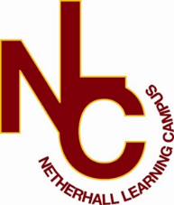

Applicant Welcome Pack
Teacher of Science

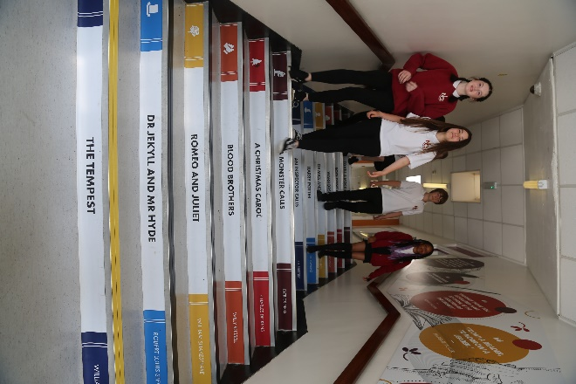
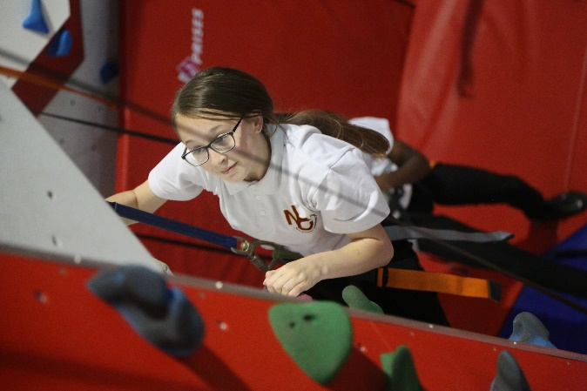

“Success For All”

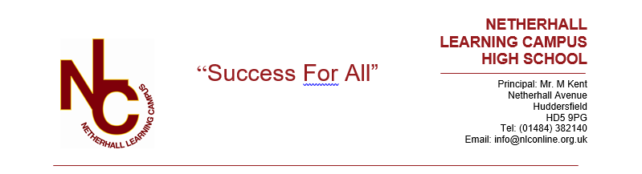

Letter from the Principal

Dear Applicant,

Welcome and many thanks for your interest in the vacancy at our school. This information pack will provide you with an outline of the role for which you are considering applying and I would encourage you to undertake further research into our school and its community to make sure this is a role in which you can make a significant, positive impact on the lives of our students. Additionally, it needs to be the right place for you to develop professionally and to be happy in the next stage of your career.

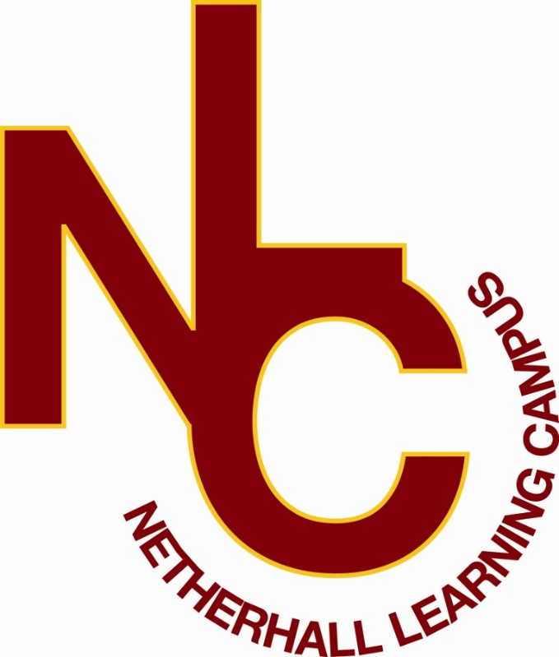
Netherhall Learning Campus consists of four schools, covering the full age and ability range from 3 – 19 years, each with its own distinctive ethos; each with its own individual identity and each catering to the specific needs of its students. Whilst the four schools are linked by a common philosophy and by common expectations, each school has its distinct and own characteristics that offer all students a continuous journey from Early Years entry through Key Stages 1 to 4 and beyond to Key Stage 5 via the Studio School. We are made up of a diverse community, yet we are all Netherhall.

Our ethos of ‘Success for All’, caring for each other and achieving excellence, underpin everything that happens in our school. I believe education should have a positive impact on all students and that Netherhall is the right place for this to happen. We have the highest expectations of all our students in every area of school life. Our school is a caring, nurturing and ordered community with an atmosphere of calm and purposeful learning. Students are treated as individuals and we recognise and celebrate different abilities, aptitudes and interests and believe that everyone can develop through dedication and hard work. We aim to create an enjoyment for learning and a resilience that is essential for achieving excellence. We work hard to ensure every young person is happy, safe and successful – a credit to themselves, their family and Netherhall. We aim high.

A culture of excellent teaching and learning is at the heart of everything at Netherhall Learning Campus and it isn’t just for students; we invest heavily in the continuing professional development of all our staff to improve the student experience. Success is not down to one thing but needs some key ingredients: strong classroom practice, an appropriate and personalised curriculum, rigorous tracking and monitoring of progress, commitment and positive behaviour for learning from students and support from home. These coupled with a love for learning and a passionate belief that all can achieve are crucial so that every student can be the best that they can be.

We look forward to welcoming you into our school community.
Michael Kent
Principal
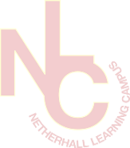
Our Vision
The vision of the Campus is one where everybody will aim to achieve the highest standards and where the Campus will maximise everyone’s potential.
We want every student to be successful at school and make excellent progress. We aim to be in the top 20% of similar schools based on achievement and progress measures. We are committed to closing the gap between those students classed as disadvantaged and those who are not, by ensuring that any gap in achievement is below national averages.
We have high expectations of student behaviour so that a positive learning environment is created that will allow all students to make progress. Our uniform policy demonstrates our high standards, we expect all students to be in the correct uniform without exception. We place great importance on attendance and aim for our attendance to be above the national average for secondary schools.
We aim to deliver consistently good lessons to all of our students and we expect them to receive regular meaningful feedback on their work. We will provide clear rules and expectations for everyone in the Campus so that we achieve consistency in all that we do. We aim to ‘do as we say’.
We want our students and parents/carers to feel valued members of the Campus community, we can only achieve this by working together. We value the input from parents to help the Campus with its work. We aim to engage parents as much as possible through regular reporting, parent’s evenings and regular parental contact. We can only succeed if we are united in our efforts.
We want all students to be engaged with their learning. We will aim to work with local employers to help enrich the curriculum, host visits and work placements, and help students find out about a vast range of careers. Our links with further education, universities and employers will help students appreciate how far hard work can take them We also aim to provide a range of additional enrichment activities for every student beyond the normal Campus day, including sports, music and drama clubs. We aim to engage with the local community through working with local primary schools, local charities and other local organisations.
We aim to encourage creativity, enterprise, teamwork, personal responsibility and leadership skills in all students. We want all students to develop a “can do” attitude that will prepare them for adult life and employment. Our aim is that every student who leaves the Campus at 16 or 18 has a place at college, university, an apprenticeship or a job.
We value every student equally and aim to provide a safe and supportive environment where bullying is not tolerated. We are aware students have different needs and as a Campus we are committed to ensuring that every student has the opportunity to succeed. This will be achieved by providing a broad, balanced and innovative curriculum that offers an excellent mix of academic and vocational pathways. We will also offer a range of interventions when needed so that no student is left behind.

“Success For All”
We will:

- provide relevant learning experiences that will enable students to acquire the essential knowledge, understanding and intellectual, physical and creative skills to equip them for later life.
- leave students at the end of their formal and full-time education with an appetite for acquiring further knowledge, skills and awareness throughout their lives.
- create high expectations of work and behaviour so that each student achieves their maximum potential.
- create a caring community whose basis is tolerance, understanding and concern for other people.
- create an inclusive and supportive environment which helps students become informed, confident, independent, involved and responsible citizens.
- encourage attitudes that enable children to be responsible members of both the school and local community and grow into well-adjusted adults and useful members of society
- recognise our responsibility to provide a safe environment in which all students feel included and valued, and in which there is celebration of all personal achievements and acceptance of diversity.
- broaden students’ horizons and increase their awareness of the world.

About the Campus

Among Kirklees schools, only Netherhall Learning Campus offers children and young adults with a continuous journey from Early Years entry through Key Stages 1 to 4 and beyond to Diploma, AS and A level studies, via the Studio School.

A continuous journey

Pupils may join any of the schools at any time. Regardless of the stage at which they start to attend, all students will experience the unique benefit of an education that has been planned by specialist teachers for all stages of a child’s learning journey.

A common standard and expectation of dress, behaviour and standards of presentation:
- All students, regardless of age, are expected to observe common rules of courtesy, respect, honesty and reliability.
- Uniform is the same across the campus.
- From the start of their school career, all pupils are expected to arrive on time and with the correct equipment.
- Work is always to be presented to the best of the pupils’ ability and books are to be respected and kept in good condition.

A recognition of the importance of parents and carers as partners in the learning journey of our children. A dedicated community team works across the campus to:
- Work with parents to help support their children.
- Encourage greater parent and carer participation in school.
- Support adults who may have had a career break, back into learning and into the workplaces.

High quality teaching
- Teachers across the campus meet regularly to share ideas and good practice.
- They share their expertise and help identify and meet the needs of pupils with special aptitude in their subject area.

Innovative curriculum development
- The curriculum is jointly planned by specialist teachers across the campus to prevent unnecessary repetition and stalling of progress at change of school.
- Creativity and opportunities for artistic and musical development are actively promoted and encouraged.

Information

Thank you for taking the time to read this pack where you will find information about the post and the school.
If you would like to be considered for the post, please complete the application form in full, alongside a letter of application, no more than two sides, outlining your relevant experience to date and the contribution you feel you could make to our school.
Please be assured that we take the time to read and consider all applications we receive. However, it is not possible to give feedback to candidates who have not been shortlisted.
We are committed to safeguarding and promoting the welfare of children and young people we expect all our staff to share our commitment. Further information regarding our safeguarding approaches can be found on our website. The successful applicant to this post will be subject to an enhanced DBS check and other pre-employment checks before the appointment is confirmed. Please note CVs will not be accepted.

Position: Teacher of Science (Fixed term 12 months)
Closing Date: 23rd April 2024 at 12pm
Interviews: w/c 22nd April 2024
Completed application forms should be returned to: admin@nlconline.org.uk
For a tour of the school, please contact admin@nlconline.org.uk

Joining Netherhall Learning Campus

- Netherhall Learning Campus High School is committed to developing all staff within their roles and creating opportunities for further career progression
- Pension – Every employee has access to the Teachers’ Pension Scheme or West Yorkshire Pension Fund.
- Emotional Wellbeing Support via Employee Healthcare Service including Care First a free confidential counselling service.
- Wellbeing Benefits include annual flu vaccination, staff gym and exercise classes
- Cycle to work scheme
- Corporate gym membership – as a Kirklees employee you are entitled to the corporate rate at all Kirklees Active Leisure gyms
- Vivup - discounts across hundreds of the UK’s high-street and online retailers
- Totum Pro – NUS card for professionals

Job Description
Post Title: Science teacher
Responsible to: Head of Science
- Responsibilities
To be responsible for carrying out the professional duties set out in the Teachers’ Pay & Conditions Document as directed by the Head Teacher within the context of the job description set out below.
- Duties
  - Curriculum
To teach throughout the school including
    - preparation of all lessons in accordance with the subject
    - keeping of a record book
    - regular marking of work in accordance with department policy
    - recording of attendance at all lessons
    - recording of assessment marks/grades
    - record of homework set
    - setting of homework in accordance with the homework timetable
    - to liaise with other members of staff to ensure that pupils’ learning is adequately supported.
  - Pupil Support and Guidance
To carry out the duties of a form tutor as necessary and/or promote the general progress and well-being of individual pupils assigned to you.
  - General
Take an active part in departmental activities and attend meetings as appropriate.
Communicating and consulting with the parents of pupils.
Communicating and co-operating with persons or bodies outside the school.
To report on pupil progress, academic or social.

Person Specification

Qualifications and experience | Essential | Desirable
Degree or equivalent in a Science discipline
Successful teaching/teaching practice across whole ability range.
Experience of `AQA Science teaching
Professional Knowledge and Skills | Essential | Desirable
Ability to teach physical/chemical sciences
Knowledge of how young people learn and the ability to apply insights to classroom practice.
Knowledge of how to plan and deliver appropriately challenging sequences of learning to pupils of all ages and levels of attainment.
Ability to effectively assess pupil learning and make a meaningful response to the insights gained from such activity so gaps in pupil’s knowledge and understanding are identified and addressed in an appropriately timely manner.
A knowledge and understanding of current educational thinking, both related to specified subject and pedagogy.
Accuracy in written and spoken English.
Ability to disseminate information to pupils in a clear and engaging manner.
Ability to accurately reflect on own practice and act on insights gained.
Ability to fulfil the teacher standards.
Ability to motivate pupils at all levels.
Knowledge of the National Curriculum and exam board specifications.
A desire to keep improving and a high expectation of self and others.
Good ICT skills and ability to use in Science context.
Personal Qualities | Essential | Desirable
Enthusiasm, perseverance, energy, flexibility.
Willingness to participate in extra-curricular activities.
Commitment to promoting the ethos and values of the school and getting the best outcomes for all pupils.
Ability to establish and maintain good relationship with others.
Ability to organise own workload, prioritise and meet deadlines.
Integrity, loyalty and personal commitment.
Excellent attendance and punctuality.
Continuing Professional Development | Essential | Desirable
Evidence of commitment to ongoing professional development.

