Year 1-12/S3 – Session 1: CVs Card Sort

Description
Gain a better understanding of how to create a solid CV.

For this session you’ll need the following Unifrog tools:

- Know-how library
- CV/Resumé tool

Why use this?
It’s important to make sure you have a good understanding of what makes a good CV - before you write yours!

Task 1
Log in to Unifrog and go to the Know-how library. Read the article ‘Acing your CV’. Once you have read the article, answer the following questions in the text box.
Unifrog tip: Complete this on a computer and save it to your Locker!
- What are the 5 main things your CV should include?

- Should you include your date of birth and a photo on your CV?

- Is it better to save your CV as a Word document or a PDF?

- Is it beneficial to make one CV which can be sent to multiple employers without any amendments?

Go to the next page for the answers - no cheating!

Task 2
Read the comments in the boxes below and then using the table provided, list the top 3 dos and don’ts of a CV. Can you add any others that aren’t listed here? Once you’ve done so, upload it to your Locker.

Top 3 Dos | Top 3 Don’ts

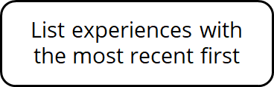
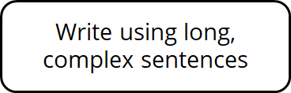
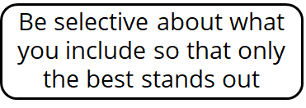

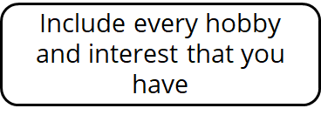
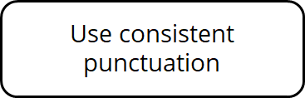
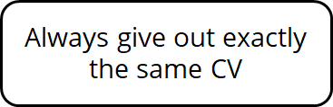

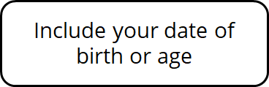
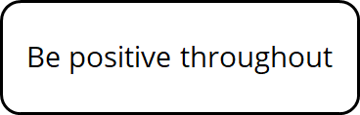
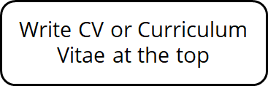

Task 3
Go to the CV/Resume tool and complete your CV. Once you have completed your CV, you can download it as a PDF or Word Document and then push it into your Locker.

Answers for Task 1:

- Contact information, work history and experience, education, hobbies and interests, references.
- While you shouldn’t usually include your age or a photo on your CV, some jobs may require it.
- It’s better to save your CV as a PDF to make sure it still looks professional when it’s opened on another computer. You can do this with the Unifrog CV builder!
- CVs should be tailored to each opportunity you are applying to. This means they can target the key skills required by that employer. You can use the Unifrog CV builder to create several personal introductions that can be used each time you need a CV.

