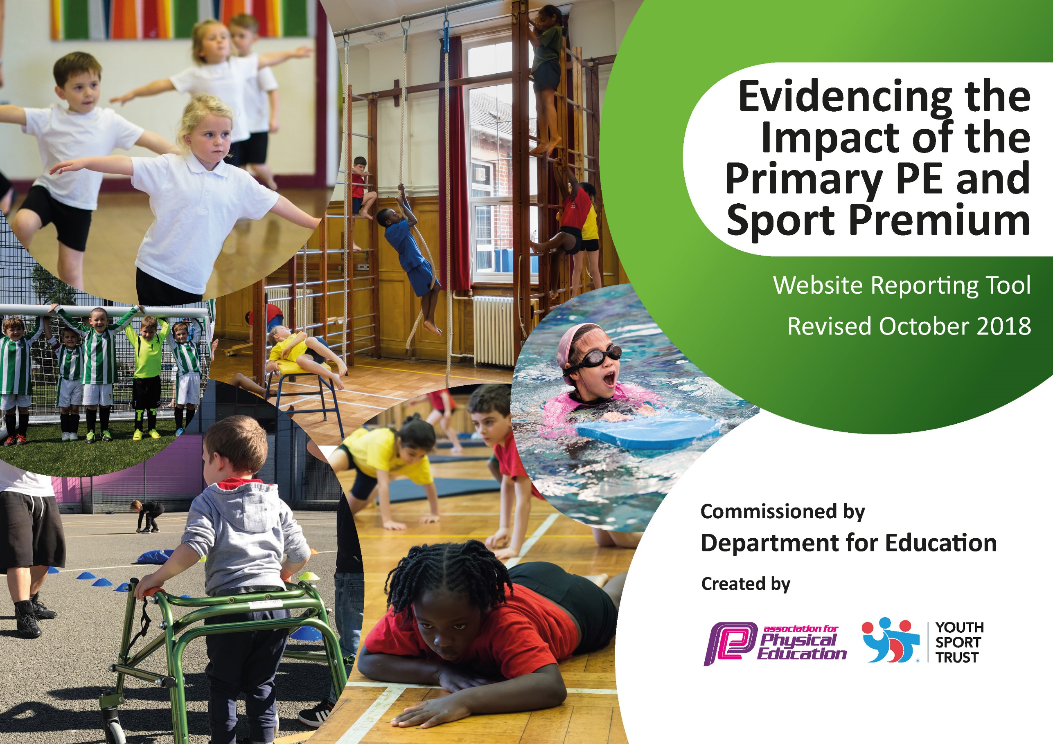
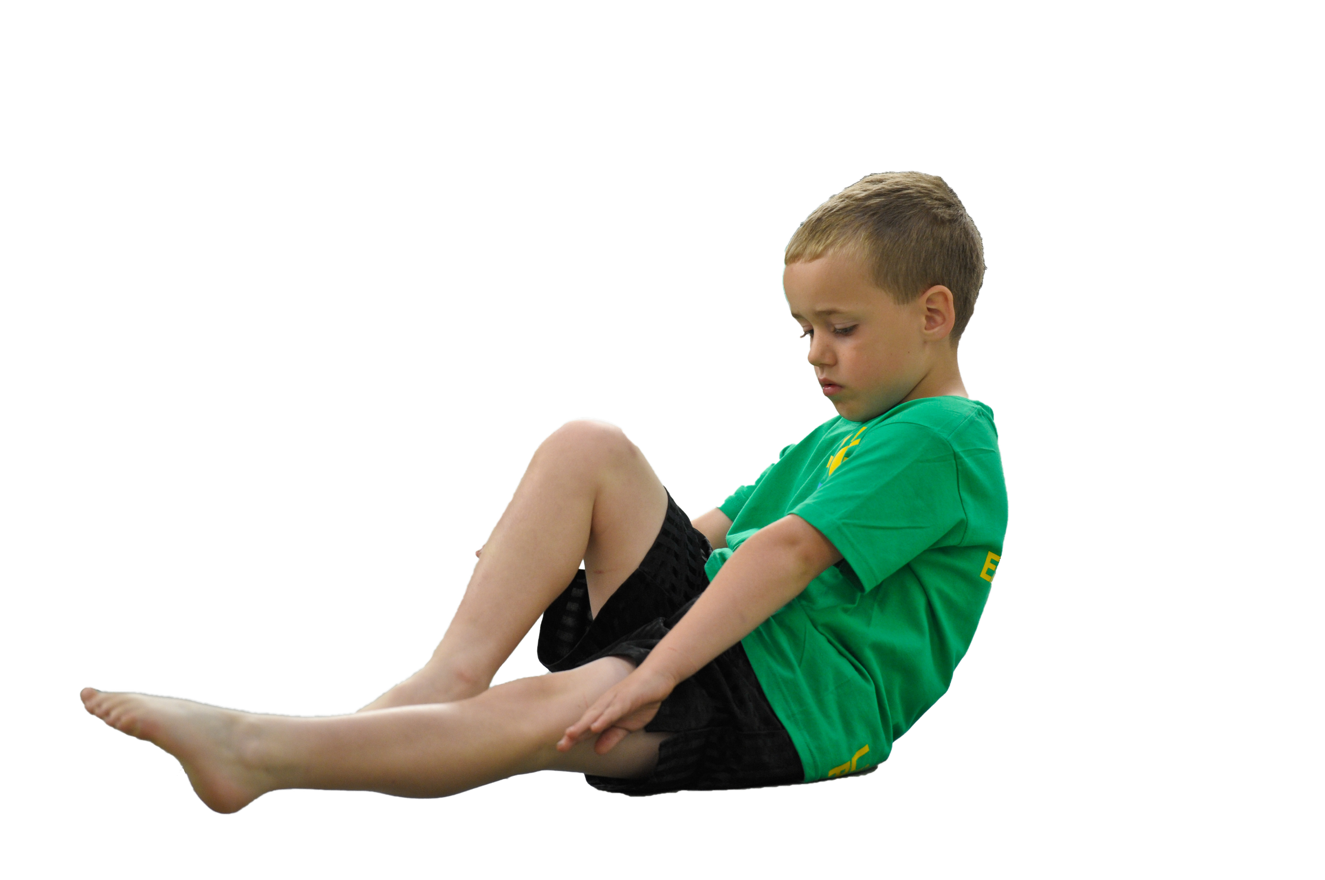
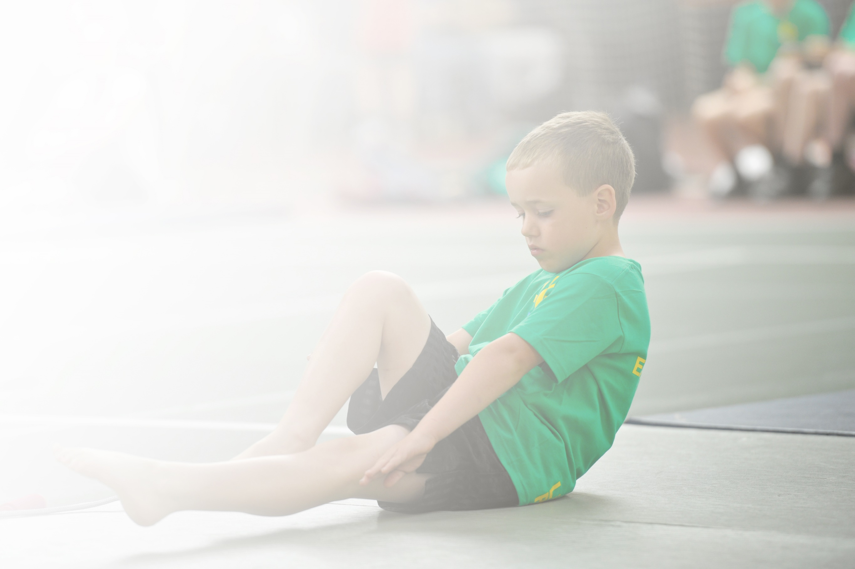
Schools must use the funding to make additional and sustainable improvements to the quality of Physical Education, Sport and Physical Activity (PESPA) they offer. This means that you should use the Primary PE and Sport Premium to:

- Develop or add to the PESPA activities that your school already offer
- Build capacity and capability within the school to ensure that improvements made now will benefit pupils joining the school in future years

Please visit gov.uk for the revised DfE guidance including the 5 key indicators across which schools should demonstrate an improvement. This document will help you to review your provision and to report
your spend. DfE encourages schools to use this template as an effective way of meeting the reporting requirements of the Primary PE and Sport Premium.

We recommend you start by reflecting on the impact of current provision and reviewing the previous
spend. Under the Ofsted Schools Inspection Framework, inspectors will assess how effectively leaders use the Primary PE and Sport Premium and measure its impact on outcomes for pupils, and how effectively governors hold them to account for this.

Schools are required to publish details of how they spend this funding as well as on the impact it has on pupils’ PE and sport participation and attainment by the end of the summer term or by 31 July 2019 at the
latest.
We recommend regularly updating the table and publishing it
on your website throughout the year, as evidence of your
ongoing review into how you are using the money to
secure maximum, sustainable impact. To see an
example of how to complete the table please
click HERE.

Support for review and reflection - considering the 5 key indicators from DfE, what development needs are a priority for your setting and your students now and why? Use the space below to reflect on previous spend, identify current need and priorities for the future.

Key achievements to date: reviewed June 2022 | Areas for further improvement and baseline evidence of need:
All KS2 received coaching support and planning support- feedback and lesson observations show PE taught to high standard across KS2  Increased variety of extra-curricular clubs offered and attended well across KS2  New equipment bought for PE to extend range of activities  New schemes of work put in place to improve progression across KS2  PE assessment tracking in place – gaps identified from COVID absence impact  House competitions continue throughout the year  Staff CPD around basic skills  Power half hour embedded as part of daily exercise  Consistently achieving the Bronze School Games award | Continued monitoring of PE teaching to ensure CPD individualised and identifies opportunities to share good practice from within school  Increase in number of children attending after school clubs  Make attempts to try and achieve Silver School Games award

Meeting national curriculum requirements for swimming and water safety – data from 2019/20 – no 20/21 swimming due to COVID closures | Please complete all of the below:
What percentage of your current Year 6 cohort swim competently, confidently and proficiently over a distance of at least 25 metres? N.B. Even though your children may swim in another year please report on their attainment on leaving  primary school. | 38%
What percentage of your current Year 6 cohort use a range of strokes effectively [for example, front crawl, backstroke and breaststroke]? | 24%
What percentage of your current Year 6 cohort perform safe self-rescue in different water-based situations? | 0%
Schools can choose to use the Primary PE and Sport Premium to provide additional provision for swimming but this must be for activity over and above the national curriculum requirements. Have you used it in this way? | Summer term 2021/22 will include catch up sessions for current Y6

Action Plan and Budget Tracking
Capture your intended annual spend against the 5 key indicators. Clarify the success criteria and evidence of impact that you intend to measure to evaluate for students today and for the future.

Academic Year: 2021/22 | Total fund allocated: £24628  Carry forward from 2020/21: £5528  2021.22 allocation £19100 (estimate) | Date Updated: September 2021
Key indicator 1: The engagement of all pupils in regular physical activity – Chief Medical Officer guidelines recommend that primary school children undertake at least 30 minutes of physical activity a day in school |  |  |  | Percentage of total allocation:
 |  |  |  | %
School focus with clarity on intended impact on pupils: | Actions to achieve: | Funding allocated: | Evidence and impact: | Sustainability and suggested next steps:
Ensuring school curriculum and delivery is high quality and ensures all children across KS2 have regular daily physical activity  All children to take part in the ‘Power half hour’ to get ALL pupils undertaking at least 30 minutes of additional activity per day at school. | Clear timetables and PE sessions for each class each day  Staff CPD planned across whole year  Planning and support available for new staff  PE kit available for all pupils – including spare kit  Monitor staff skills/knowledge  Monitor lessons and quality of learning and teaching within PE  Gather pupil voice | £15600 - Project sport - coach 2.5 days a week including 3 extra-curricular clubs a week | Timetables will be set and monitor provides evidence that physical activity is being completed daily by all children  Baselines of basic skills completed starting at Y3 to ensure teaching to meet needs of pupils and progression from right starting points  Children will feedback positively about their physical activity programme  All children can take part in PE with PE kit  SIMs and CPOMs behaviour analysis will show a reduction in disruption in lessons from identified vulnerable groups ( SEN (SEMH) boys) | Identify vulnerable/target group as case study of impact  Link this case study to pupil progress and specific teacher focus on an individual and impact on health and well being in school.  Power half hour firmly embedded in school day.
Key indicator 2: The profile of PESSPA being raised across the school as a tool for whole school improvement |  |  |  | Percentage of total allocation:
 |  |  |  | %
School focus with clarity on intended impact on pupils: | Actions to achieve: | Funding allocated: | Evidence and impact: | Sustainability and suggested next steps:
Pupils to experience high quality PE and Sport by ‘up skilling’ staff in PE subject specific knowledge  Provide extra-curricular clubs and inter school competition events for every year group throughout year  House assembly and competitions linking to PE, celebrating achievements. | House system linked to PE events  All teachers providing high quality curriculum for all pupils  All teachers to attend/support PE lead with extra-curricular/competition event  Monitoring of PE within QA cycle  CPD planned into school CPD calendar  PE displays termly  SPIN events across the year to engage children in competitive events and increased day from coach and G&T tournaments and festivals  Additional equipment to improve/increase sports delivered eg boccia, new age curling | Coach and CPD  SPIN membership –  £2560  £1691 | 2 termly House PE events completed  QA monitoring evidence of standards of learning and teaching  CLICK milestone analysis shows increase in % of children achieving NC statements in PE  2 PE planned CPD events - teacher feedback and evaluation is positive and constructive  Displays celebrate PE across school and evidence skills and knowledge developed by children  House Captains/SSOC (School Sports Organising Crew) to assist MT with planning and running of events  Staff CPD, visit events or extra curricular clubs for pupils will be attended | CPD calendar planning with PE coordinator  Identify NC statements and analysis tool to use for CLICK milestones  Ensure teacher feedback taken from CPD events - leads into next planned CPD session  Pupil voice and celebration of developments - good practice? What are other schools doing?  MT to hold half termly meetings with House Captains

Key indicator 3: Increased confidence, knowledge and skills of all staff in teaching PE and sport |  |  |  | Percentage of total allocation:
 |  |  |  | %
School focus with clarity on intended  impact on pupils: | Actions to achieve: | Funding  allocated: | Evidence and impact: | Sustainability and suggested  next steps:
In order to improve progress and achievements of all pupils the focus is on up-skilling the staff. | Specialist coaches to lead and then assist class teachers in PE lessons – planning shared and adapted together to meet needs of pupils  MT to assist class teachers with planning/teaching where needed  Baseline pupils so that impact can be measured over time | Project Sport costs  SPIN support | Better subject knowledge for teachers and TA’s, with the latter being more confident to take a more active role in lessons  Increased confidence and better subject leadership skills enabling the subject leader to lead professional learning for all staff  Subject leader more confident when undertaking lesson observations/team teaching – able to provide effective feedback and lead discussions.  WIDER IMPACT AS A RESULT OF ABOVE  - Skills, knowledge and understanding of pupils are increased significantly  - Pupils really enjoy PE and Sport, are very keen to take part and demonstrate a real desire to learn and improve | MT to carry out informal drop-ins – teacher confidence questionnaire  Project Sport coaches feedback on lessons  Subject lead to attend network and SPIN meetings and feedback to staff
Key indicator 4: Broader experience of a range of sports and activities offered to all pupils |  |  |  | Percentage of total allocation:
 |  |  |  | %
School focus with clarity on intended  impact on pupils: | Actions to achieve: | Funding  allocated: | Evidence and impact: | Sustainability and suggested  next steps:
Specialist PE teacher/coach providing children with a variety of sports and activities at a high standard  Extra curricular programme is broad and offers variety to each year group throughout school year | Map across KS2 sports/games taught in each term – skills progression focus to address COVID gaps  Liaise closely with Coach to develop and extend activities provided after school – listening to pupil voice and adapting clubs  Review and evaluate planning each term and adapt to improve - include pupil and teacher feedback on sports/activities taught  Wherever possible, target vulnerable groups/PP children/overweight children?  (inactive girls) | Project sports funding | Map completed and QA evidence of sports being taught  Planning incudes broad spectrum of sports and allows for progression of skills  Pupil voice and teacher feedback is positive and constructive towards next steps  Wide variety of PE lessons/clubs inc ‘different’ sports (Jui Jitsu, Fencing, handball, Boccia etc) | Evaluate sports/activities taught over last 2 years - what would a child experience in their journey through PE and Sport at our school?  Map CPD and skills training against the broad spectrum of sports - identify skill strengths in staff  Gather parent and pupil voice and consider next academic year budget – school staff involvement
Key indicator 5: Increased participation in competitive sport |  |  |  | Percentage of total allocation:
 |  |  |  | %
School focus with clarity on intended  impact on pupils: | Actions to achieve: | Funding  allocated: | Evidence and impact: | Sustainability and suggested  next steps:
Half termly House/PE competitions  School Sports day  SPIN events | SPIN events entered at Junior school with others from Huddersfield including G&T tournaments and matches |  | School to be awarded School Games Bronze overall (Silver and Gold in most categories however) | Only area stopping us getting Silver award is the no of children attending after school clubs each week. Currently c.50 and needs to be c100.  MT to continue to monitor upcoming events and to enter a variety of competitions to ensure all year groups etc are included

